COMPUTING SUBJECT: Arrays of user defined classes

TYPE: GROUP WORK ASSIGNMENT

IDENTIFICATION: BORROWERFILES/MC

COPYRIGHT: Michael Claudius

DEGREE OF DIFFICULTY: Easy

TIME CONSUMPTION: 2-6 hours

EXTENT: 50 lines

OBJECTIVE: File handling of collections of objects

COMMANDS:
IDENTIFICATION: FANTASY LIBRARY NO5: BORROWERFILES/MC

The mission
You are to develop a program, which can manage, control and handle collections of borrowers at the Fantasy Library by using files. The management of borrowers has already been implemented in a GUI based program. It would be nice to extend the program with the possibility to write/read objects to/from files

The objective
We want a program, which permanently can register and keep records of borrowers utilizing the previously made BorrowerRegister and BorrowerRegisterGUI.

The problem
You are to develop program, which can to write/read objects to/from files. Due to the requirement specification the following functionality has been identified for the functionality BorrowerFileHandler:

NO. | USE CASE NAME | DESCRIPTION
1 | BorrowerWriteFile | Write the collection of borrowers to a file
2 | BorrowerReadFile | Read the file into the collection of borrowers
3 | BorrowerSplitFile | Split the file into two files depending on age
4. | BorrowerSortedFile | Read the file, sort the borrowers and save it
-

The first design -for reason of simplicity- shows all methods encapsulated in one Register class in the ControllerManagementComponent (CMC) named BorrowerRegister and one Controller/handler class named BorrowerFiling as shown below:

This design we will split into the following 4 classes (Sun-style):
- BorrowerWriteFile, BorrowerReadFile, BorrowerSplitFile, BorrowerConcatenateFile

First we only look at the class BorrowerWriteFile:

Datafields:
private Borrower aBorrower;
private BorrowerRegister borrowerCol;
private String fileName;

Constructor
BorrowerWriteFile(BorrowerRegister br, String fileName)

Methods operating on the data fields
public void doIt()

Assignment 1: Controller Class BorrowerWriteFile: constructor

In your favourite editor create the Java Main Class BorrowerWriteFile with two private datafields and the following constructor and method:

BorrowerWriteFile (BorrowerRegister borrowerCol, String fileName)
Initializes the data fields to the parameters

Thus the start of the class resembles the following:

public class BorrowerWriteFile {

//define the 3 datafields, doit yourself

BorrowerWriteFile (BorrowerRegister borrowerCol, String fileName) {
//initialize the datafields to the parameters
}

} // BorrowerWriteFile

Compile!

Assignment 2: Controller Class: BorrowerWriteFile method
Extend the class BorrowerWriteFile with the following method:

- public void doIt()
Creates and declares a FileOutputStream and an ObjectOutputStream.
Writes the number of borrowers to the file.
Traverses the collection of borrowers and write each object to the file.
Finally closes the object output stream.
Catchs an IOException in case of errors with file writing

Thus the doIt() looks like the following:

public void doIt() {

try {
//declare a FileOutputStream fos; do it yourself
//declare a ObjectOutputStream oos; do it yourself
int number = borrowerCol.numberOfBorrowers();
oos.writeInt(number);
for (int index = 0; index < number; index++) {
aBorrower = borrowerCol.getBorrower(index);
oos.writeObject(aBorrower);
} //for
//close oos; do it yourself
}//try

catch (IOException ex) {
System.out.println(ex.getMessage());
ex.printStackTrace();
}

}// doIt

Assignment 3: Application and test in main in BorrowerWriteFile
In the main you must try to test the class by declaring an object of BorrowerRegister using 3 objects of the Borrower class. In main show these constructions:

- declare and construct the object, borrowerCol ,of the class BorrowerRegister
- declare and construct the 3 objects, b1, b2, b3, of the class Borrower
- add the these borrower-object to the collection of borrowers
- declare a file name.
- declare and construct an object, cmc_WriteFile of the class BorrowerWriteFile
- write the borrowers to the file by calling the method cmc_WriteFile.doIt().

Check the folder and see if you can find the file.
Try to open the file inTextPad.

Tip:
File names can be tricky if you want to write on H-drive. Use something like this:
“H:” + “\\” + “SW-Construction” + “\\” + “Solutions” + “\\” + “borrower.data”

So far so good ! Now let's look at reading from a file.

Assignment 4: Controller Class: BorrowerReadFile
To read from a file create a new class BorrowerReadFile resembling the following:

Datafields:
private Borrower aBorrower;
private BorrowerRegister borrowerCol;
private String fileName;

Constructor
BorrowerReadFile(BorrowerRegister bc, String fileName)

Methods operating on the data fields
public void doIt()

Start by copying BorrowerWriteFile class to a new BorrowerReadFile.class.
Change the doIt method into the following:

- public void doIt()
Creates and declares a FileInputtream and an ObjectInputStream.
Reads the number of borrowers from the file.
Traverses the file, reads a borrower object and add this object to the collection.
Finally closes the object input stream.
Cast an IOException in case of errors with file reading
Cast a ClassNotFoundException incase of errors with the class

Compile!

Assignment 5: Application and test in main in BorrowerReadFile
In the main you must try to test the class by declaring an object of BorrowerRegister. In main show these constructions:

- declare and construct the object, borrowerCol ,of the class BorrowerRegister
- declare a file name.
- declare and construct an object, cmc_ReadFile of the class BorrowerReadFile
- read the borrowers from the file by calling the method cmc_ReadFile.doIt().
- print all the borrowers data

So far so good ! Now let's look at GUI implementations.

You are to have two GUI-classes. One major class BorrowerRegisterFileGUI managing a borrower collection and resembling the following:

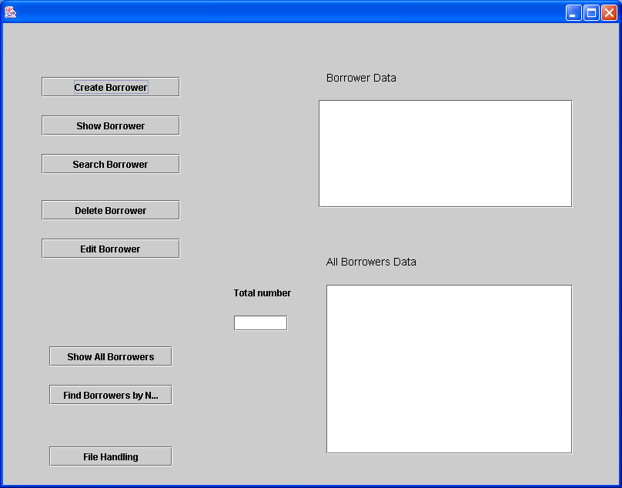

Notice the button “File Handling”.
When this button is clicked a new window BorrowerFilingGUI pops up, resembling the following

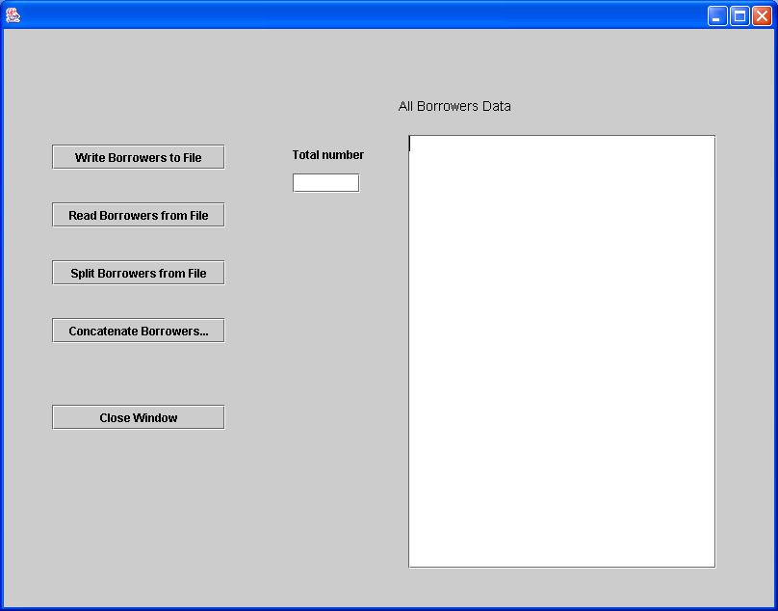

As you can see there are five JButton (writeButton, readButton, splitButton, concatButton, closeButton), two JLabel (allDataLabel, noLabel), one JTextField (numberTextField) and one JTextArea ( allDataArea). Note that the allDataArea is empty at starting point, whereas numberTextField shows 0 at starting point.
What you cannot see is that a JScroolPane is assigned to each JTextArea. Remember to do this..

In this window we are still working on the same borrower collection, handling some filing by utilizing the 4 file controller classes.
When clicking on the Button “Close Window” the window is closed and now BookRegisterFileGUI is active again.

This will now be explained more detailed on the next pages.
Assignment 6: Presentation Class: BorrowerFilingGUI

In NetBeans create a Java GUI Form named BorrowerFilingGUI with the buttons and textfields/areas as described on the previous page.

Then extend it with the following:

Data fields:
BorrowerRegister borrowerCol
Borrower aBorrower

Constructors
public BorrowerFilingGUI()
Initialises the components (i.e. initComponents)

public BorrowerFilingGUI(BorrowerRegister borrowerCol)
Initialises the components (i.e. initComponents)
Initialises the data field with the parameter.

Methods
public void closeWindow()
Disposes the window
Must be called when the closeButton is clicked.

- public void writeBorrowersToFile()
Reads in a file name from the screen. Declares and construct an object, cmc_WriteFile of the class BorrowerWriteFile and write the borrowers to this file by calling the method cmc_WriteFile.doIt().
Must be called when the writeButton is clicked.

Compile and execute and write to a file !

Assignment 7: Presentation Class: BorrowerFilingGUI
Extend the class BorrowerFilingGUI with the following method:

- public void readBorrowersFromFile()
Reads in a file name from the screen. Declares and construct an object, cmc_ReadFile of the class BorrowerReadFile and read the borrowers from this file by calling the method cmc_ReadFile.doIt().
Must be called when the readButton is clicked.

Compile and execute and try to read from the same file !

Tip:
File names can be tricky if you want to write on H-drive. Use something like this:
“H:” + “\\” + “SW-Construction” + “\\” + “Solutions” + “\\” + “borrower.data”
Assignment 8: Presentation Class: BorrowerRegisterFileGUI
In Netbeans create a Java GUI Form named BorrowerRegisterFileGUI by copying BorrowerRegisterGUI. Then extending it with a JButton fileButton and a method:

- public void fileHandling()
Declares an anonymous object of the class BorrowerFilingGUI.
Transfers the borrower collection to this new window
Activates the window by calling the show method
Must be called when the fileButton is clicked

Thus the fileHandling method resembles the following

private void fileHandling() {
new BorrowerFileHandlingGUI(borrowerCol).show();
this.setFocusable(true);
showNumbers();
}

Assignment 9: Controller Management Class: BorrowerSplitFile
To split a file into two files create a new Java class BorrowerSplitFile resembling the following:

Datafields:
private Borrower aBorrower;
private BorrowerRegister borrowerCol;
private String String inputfileName, childrenFileName, adultFileName;
private BorrowerRegister children, adults;

Constructor
BorrowerSplitFile( String inputfileName,
String childrenFileName,
String adultFileName)

Methods operating on the data fields
public void doIt()

The doIt method has the following responsibility:

- public void doIt()
Reads the borrowers from the input file and depending on the borrower type (bType) save a borower in a child borrower collection or an adult borrower collection. Finally it writes two collections to two new files.

Extend the BorrowerFilingGUI to handle this functionality

Assignment 10: Controller Management Class: BorrowerConcatenate Files
Try to extend your program to concatenate two files into one ! ???

