COMPUTER SUBJECT: SECURITY AND CRACKING

TYPE: GROUP WORK EXERCISE/DISCUSSION

IDENTIFICATION: HASHCAT/MC

COPYRIGHT: Michael Claudius

LEVEL: INTERMEDIATE

DURATION: 30 - 90 minutes

SIZE: 10 lines!!

OBJECTIVE: Cracking passwords using GPU

REQUIREMENTS: Network Security Essentials

COMMANDS:

IDENTIFICATION: HASHCAT/MICL

Prolog
You have by now investigated password cracking using word-dictionary and brutal force.

The Mission
You are to explore the most powerful cracking program in the world named Hashcat, which is utilizing the GPU (Graphical Processor Unit) on the computer.

Purpose
The purpose is to learn the possibilities provided by Hashcat as a cracking tool.

Useful links
www.hashcat.net Also link to Videos

How to crack passwords using hashcat
Fine fast introduction to hashcat

Cracking using graphic processors video
A rather talkative and too long introduction. Just watch minutes: 0-1, 3-6
Crack WPA2 network
Tutorial on a PMKID hashcat Attack

How to use hashcat youtube video
Instructions on hashcat, rather primitive and long

Assignment 1: Download hashcat

Go to www.hashcat.net and you will see the following web-page:

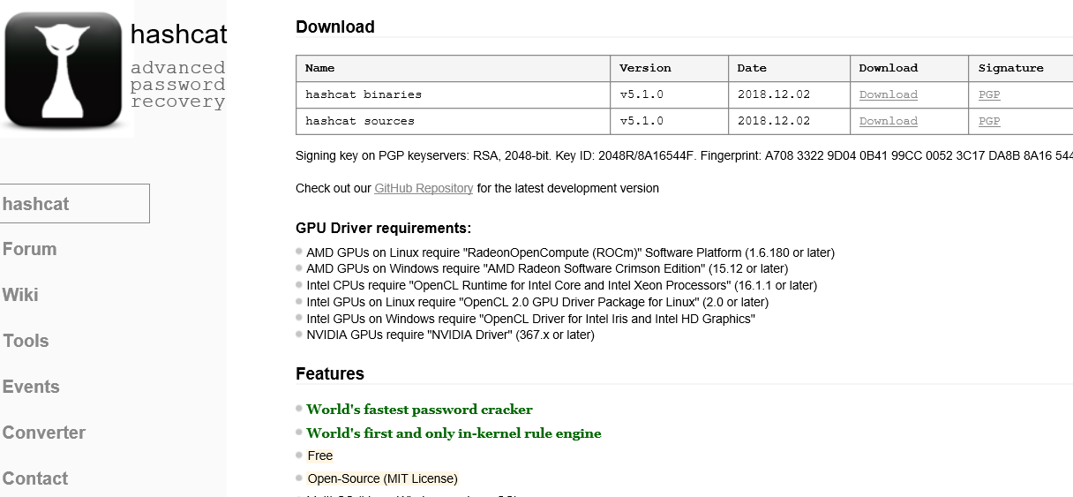

Download the little older version v5.0.0 zip file.
Either as:
Hashcat binaries, which is a standard set-up that must match the operating system. Recommended for Windows
Or as:
Hashcat sources, which will be compiled on your computer,
Recommended for Unix/Linux and maybe Window VM on MAC

Find an appropriate directory and unzip the file to hashcat-5.0.0.

Then rename hashcat32.exe (if you are on a 32-bit machine) or rename hashcat64.exe (if you are on a 64-bit machine) as hashcat.exe.

Furthermore, create an empty text-file output.txt and a sub-dictionary named wordlist.

Assignment 2: Explore hashcat
Watch the video How to crack passwords using hashcat

Open a command prompt and change directory to the hashcat directory (e.g: cd C:\hashcat-5.0.0)
Type:
hashcat

Use help command

hashcat –-help

and the home page to investigate the possibilities

- Options
- Attack types
- Hashing modes
- Char set
- Workload performance
And more….

Assignment 3: Cracking
In example0.hash a list of hashed passwords using MD5 are given.
Open a command prompt and change directory to the hashcat directory (e.g: cd C:\hashcat-5.0.0)
First make a copy of the file:

copy example0.hash myexample0.hash

as the hashes might be removed when cracked.
Secondly, we shall use brute force (option –a 3) and MD5 (option –m 0) for the cracking of passwords 6 characters long (?a?a?a?a?a?a).
Type:
hashcat -a 3 -m 0 example0.hash ?a?a?a?a?a?a

Hopefully you will see something like:
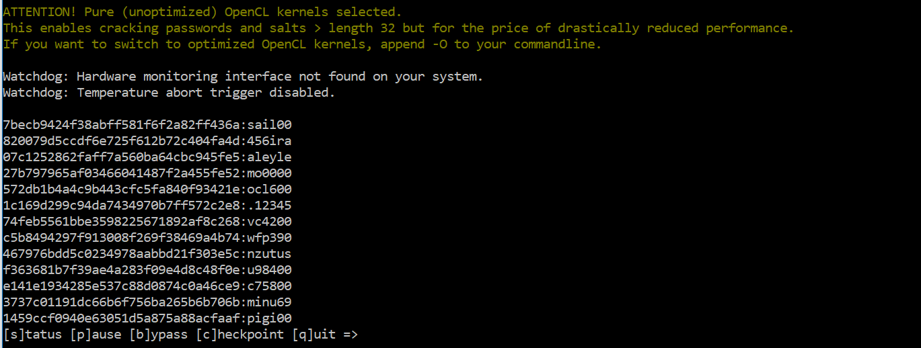

If there are problems with openCL then add option “--force”

hashcat -a 3 -m 0 example0.hash ?a?a?a?a?a?a

this will slow down the cracking speed, but you will get the feeling of hashcat.

Alternatively try to append the option “-0” to the commandline.

The cracked passwords might also be collected in the file hashcat.potfile. Take a look at the file or just use the command “type”.

Investigate and enjoy other commands.

Assignment 4: Your own cracker
Try to run hashcat on the hashed passwords from the mandatory assignment.
Line exceptions !!
THINK!
Not cracking !!
THINK !!

