COMPUTING SUBJECT: Certificates for SSl

TYPE: Assignment

IDENTIFICATION: CertificateX509

COPYRIGHT: Michael Claudius

LEVEL: Medium

TIME CONSUMPTION: 1-2 hours

EXTENT: 50 lines

OBJECTIVE: Windows SDK, makecert, pvk2pfx, mmc

PRECONDITIONS: Computer Networking Ch. 8.5

COMMANDS:
IDENTIFICATION: CertificateX509/MC

Mission
You are to make a secure connection communication by setting up a server and a client using the secure socket layer (SSL) by sharing the certificate provided by the server. This we shall do in three steps/assignments:

- CertificateX509, Install Windows SDK and investigate the tools mmc, makecert & pvk2pfx
- CreateCertificateX509, Create self-signed X509 Root and Server SSL certificates
- Secure SocketsC#, Use the certificates and SSLStream for secure socket communication

This assignment is the Assignment No.1

Purpose
The purpose of this assignment is to install Windows SDK and learn about the tools mmc, makecert and pvk2pfx.

When surfing on the net it is easy to find many descriptions more or less useful, and in more or less updated versions. Here are some:

Useful links for C#:

How to install Window SDK for Windows 10
https://dev.windows.com/en-us/downloads/windows-10-sdk

View certificates using the tool mmc snap in/out
https://msdn.microsoft.com/en-us/library/ms788967(v=vs.110).aspx ;

Description of makecert tool:
https://msdn.microsoft.com/en-us/library/ms733813(v=vs.110).aspx

Description of pvk2pfx tool:
https://msdn.microsoft.com/en-us/library/windows/hardware/ff550672(v=vs.85).aspx

Link describing opening command prompt used by Visual studio
https://msdn.microsoft.com/da-dk/library/ms229859(v=vs.110).aspx

Description of thumbprint
https://www.thesslstore.com/blog/ssl-certificate-still-sha-1-thumbprint/

Useful links for Java: Keytool
Solaris Programmers tool to create keys
Keytool - Key and Certificate Management Tool

Windows Programmers tool to create keys in Java
Keytool – Key and Certificate Management Tool
1. Install Windows SDK kit
To be able to create certificates for secure socket communication one must use the tool makecert and pvk2pfx as defined in Window SDK. Therefore, see if you can find a path like:

C:\Program Files(x86)\Windows Kits\10.\bin\x64

With two files: makecert and pvk2pfx.
If not install Window SDK for Windows 10, if you have not done it already. Use the link:

https://dev.windows.com/en-us/downloads/windows-10-sdk

And download and install the SDK standalone version for Windows 10.

Then check that you can access and run makecert from the command prompt.
Start a command-prompt.
Click Start => Programs => Accessories => Command prompt
Or just Start => cmd
Give the command makecert:

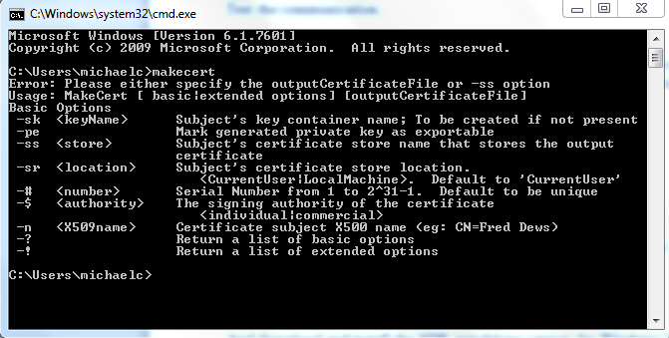

Also try to check out the pvk2pfx command in the same way. If a command is not recognized you must change the environment variables PATH (Path) and maybe CLASSPATH.

A) Set your environment variable Path to include present working directory (.) and your folder with the Windows SDK it (e.g. C:\Program Files(x86)\Windows Kits\10.0\bin\x64)
For more details; See the Appendix A on environment variables at the end of this document.

B) If you can run e.g. makecert but not pvk2pfx, this is due to permission- restriction on the file-location..
For more details; See the Appendix B setting permission of folder.

Maybe
C) Set your environment variable CLASSPATH to include the folder (working directory '.' - dot). Not in Windows 10!.

2. Investigate makecert and pvk2pfx tools
What is the purpose of makecert ?
Explain the various options like -sky -n -r etc.

What is the purpose of pvk2pfx ?
Explain the various options like -pvk -f etc.

Wonder how many of these are important…..

Tip: Make use of the following links
Description of makecert tool:
https://msdn.microsoft.com/en-us/library/ms788967(v=vs.110).aspx
https://msdn.microsoft.com/en-us/library/ms733813(v=vs.110).aspx

Description of of pvk2pfx:
https://msdn.microsoft.com/en-us/library/windows/hardware/ff550672(v=vs.85).aspx

3. Certificate repository
Use the tool mmc snap in/out (the Internet browser and/or) to find out which certificates you already have on your computer.
Start a command prompt: Start => cmd
Type: mmc
Choose: File => Snap In/out => Certificates => Add => Computer Account => Next =>
Local Computer => Finish => OK

Now, take a close look at some of the trusted certificates and personal certificates on localhost.

Guess you will be surprised!
Appendix A: Environment variables Path in Windows 10
- Select Start => Control Panel
- Choose System and Security => System
- Click Advanced system settings > Advanced tab
- Click on Environment Variables, and under System Variables, find Path, and click on it.
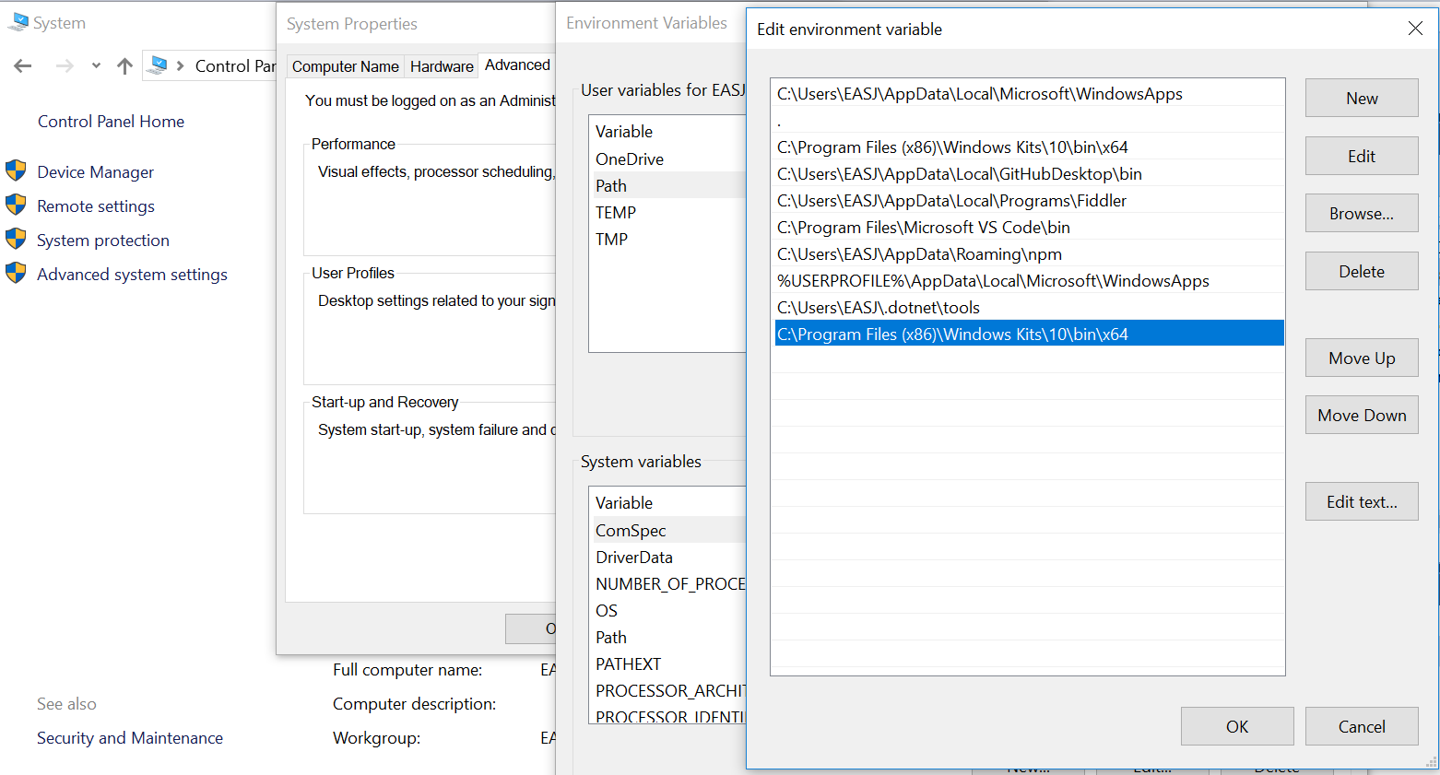

- Click on Edit and in the Edit windows, choose Path then cloick on New and add the directory of the respective file to the value for Path.
(If you do not have the item Path, you may select to add a new variable and add Path as the name and the location of the class as the value. Remember the semicolons as splitter characters!!)
- Click OK everywhere
- Reopen Command prompt window, and run the command again.
Maybe you will have to restart your computer….

Appendix B: Setting permission of folder.
- Open the Windows explorer (pat- finder == stifinder) Start
- Find the folder holding the files (e.g. C:\Program Files(x86)\Windows Kits\10.0\bin\x64)
- Right click on Properties
- Untick the Attributes box
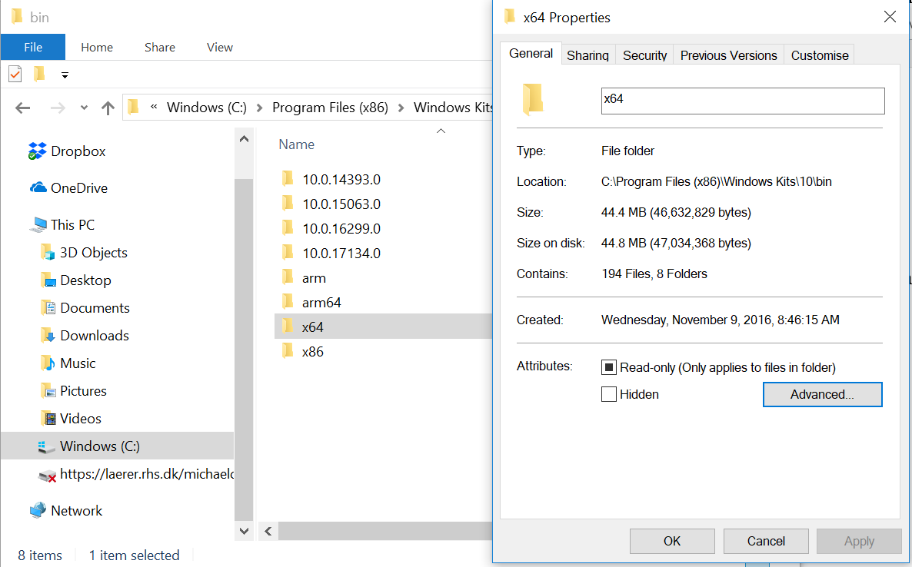

Finally click OK everywhere.

Appendix C: Environment variables Path in Windows 7
- Select Start => Control Panel
- Choose System and Security => System
- Click Advanced system settings > Advanced tab
- Click on Environment Variables, and under System Variables, find Path, and click on it.
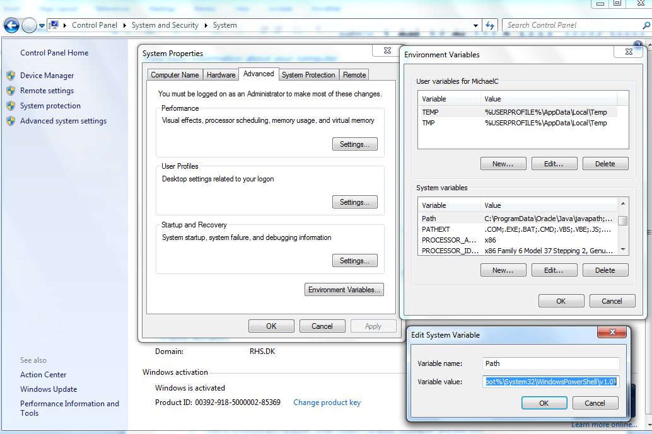

- Click on Edit and in the Edit windos, modify Path by adding the directory of the respective file to the value for Path. If you do not have the item Path, you may select to add a new variable and add Path as the name and the location of the class as the value. Remember the semicolons as splitter characters!!
- Click OK everywhere
- Reopen Command prompt window, and run the command again.
Maybe you will have to restart…!

