COMPUTING SUBJECT: UDP Socket programming

TYPE: Assignment

IDENTIFICATION: UDPSensor

COPYRIGHT: Michael Claudius

LEVEL: Intermediate

TIME CONSUMPTION: 1-2 hours

EXTENT: 20 lines

OBJECTIVE: UDP-sockets receiving data from a sensor

PRECONDITIONS: Computer Networks Ch. 2.7

COMMANDS:
IDENTIFICATION: UDPSensorPolution

The Mission
We are shall explore receiving data broadcasted on the net from a pollution sensor placed in the teachers room. The sensor is continuously sending out data on the local LAN.

Domain description
By the bus stop by the school in Roskilde is set up a sensor, which can measure the important pollution factors: CO(measured in mg), NOx(measured in ug) and small particles concentration(Alarm, High, Normal, Low). These data are sent out on the nearby school-LAN by UDP-broadcasting on port 11111. A data set has the following format:

Pollution sensor v.1.0. \r\n
Location: Maglegårdsvej 2
Time: 04-Oct-17 12:34:42 PM
CO: 0.38 \r\n
NOx: 140.30 \r\n
Particle level: Medium \r\n \r\n

Right now you have a solution for UDP number receiving: UDPNumberReceiver and UDPEchoClient, which are good starting points for this assignment.

Assignment 1: Application class: UDPSensorRecceiver
- Create a new Console Application project, UDPSensorReceiver, with the usual main method, which apply UdpClient for listening on port 1111.
- Extend the program to:
- Capture sensor data and print them to the console.
- Split the data into the individual text-lines values and print them to the console.
- Save the numerical values of CO and NOx in appropriate variables.
Print out these variables as well.
When running you should receive some data like:
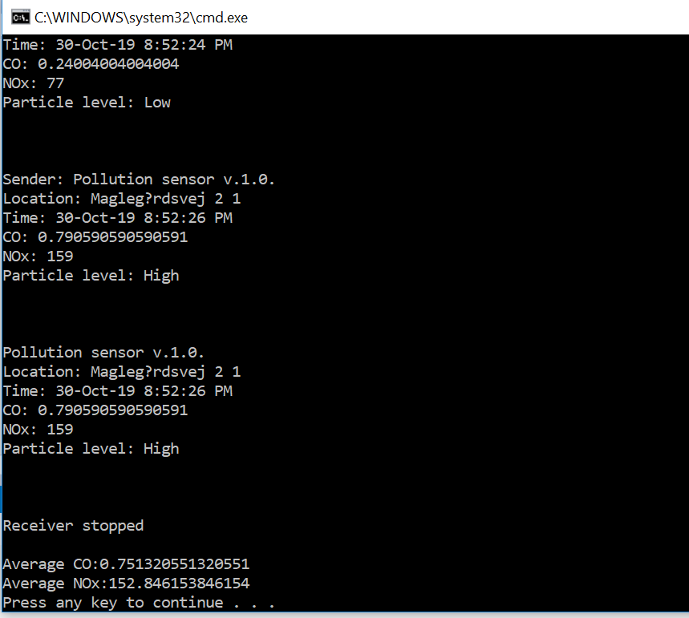

Depending of course what you decide to print out.

Assignment 2: Analyzing data
Extend the program so it is calculating the sum of the measured numerical values inside the while-loop.

Assignment 3: Stop the receiver
Create a new project UDPSensorStop, which sends a “Stop” command to the port on which the receiver is listening. When stop-command is received, the receiver’s while-loop is stopped and it print out the sum and average of the measured values.

Assignment 4: Your own broadcaster
Create a new project UDPSensorBroadcast, which simulate a sensor; i.e. it sends the pollution data as described. Try to receive the data from this broadcaster.

