COMPUTER SUBJECT: VIRTUALISATION

TYPE: INDIVIDUAL WORK EXERCISE

IDENTIFICATION: Installation of Docker/Pele

COPYRIGHT: Peter Levinsky

LEVEL: EASY

DURATION: 1-1½ hours

SIZE: NA

OBJECTIVE: Using Docker as virtualisation

REQUIREMENTS: note of virtualisation

COMMANDS:

IDENTIFICATION: Installation of Docker /Pele

Installation of Docker

The Mission
We shall work with virtualisation on the computer, thus this exercise will describe how to install Docker on Windows,. If you have another OS see at the Appendix on last page.
When you have passed this exercise you will have Docker up and running and will be ready for actually try out the virtualisation (see the coming exercises).

For additional background information, you can see / read these sources:
- The Docker homepage https://www.docker.com/ and
the documentation https://docs.docker.com/
- Video of The Docker and the installation https://www.youtube.com/watch?v=Lnbu74R1CIM&index=3&list=PLtWgqZUXAsNhMnuVgkP-nIuuKrRHuVF4Q
- Installation guide from Docker to Windows https://docs.docker.com/docker-for-windows/install/

Assignment 0: Setup preconditions
Before your computer can support or run Docker, your computer need to:
- Enable virtualization in the hardware or more precise the BIOS.
- Run an OS supported by Docker.

Enable virtualization
Most computers are setup to have their Virtualization disabled as default. Therefore, if you not already have run a virtual machine you will properly need to go into BIOS settings and enable virtualization.

Each computer vendor have their own way to start their BIOS settings so if you do not know, search on the network to see how. Normally you need to shut down the computer to start BIOS settings (cold restart) not just restart (warm restart).

You will most likely find the setting for virtualization under the menu CPU or similar.

Supported OS
The Docker can run in these Windows OS’s Windows 10 64 bit Pro, Enterprise and Education (1607 Anniversary Update, Build 14393 or later). Therefore, it do not run on Windows 10 home.

Check your system by open a file-explore right-click on ‘This PC’ choose properties, and then you can see the Windows edition.

If you run a home edition, please follow the guideline in https://helpdesk.easj.dk/hc/en-us to access Imagine / Dreamspark to download and upgrade to Windows 10 education (or Pro or Enterprise).

For Other type of OS, please follow the guidelines from Docker documentation https://docs.docker.com/engine/installation/

Assignment 1: Download and install Docker
First, download the Docker from https://download.docker.com/win/stable/InstallDocker.msi
Then run the msi-file to install Docker.
You will see something like this:

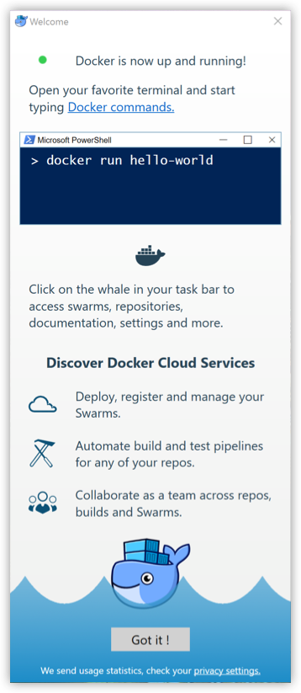
You can then click ‘Got it’.
Then you are asked to turn on the Hyper-V, which you can accept. Even this will prevent you to run a VirtualBox if you have this running.

Note! You do not need to be able to run Windows-containers in this course; therefore, you can live without having the Hyper-V enabled.

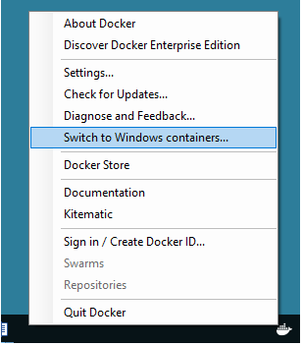
You can afterwards turn on the windows containers. Then the Hyper-V will be enabled – You then must then reboot your computer

Right click

Assignment 2: Investigate Docker
You should now have Docker running and now it is time to see what Docker is.
Sso first step is to open a terminal window (either a Command Prompt or a Windows PowerShell).

Now you can write several commands – here are some important commands for the moment:

- To get help (a list of possible commands)
docker
docker –help
- To see the version of the Docker
Docker version
- To get a list of setup information for the Docker
Docker info
You will among other information be able to see numbers of containers/images, running Docker virtualisations, operating system (either Linux or Windows depending of your switch of containers – see assignment 1)

Assignment 3: Setup access to Dockers registry of containers
Docker is working with Containers or Images. These containers are located in the registry http://hub.docker.com . To get access to these you can create an account at hub.docker.com, which by the way will be the same account to docker.com.

To setup an account use: https://hub.docker.com/

Try to sign in and explore the registry – you will see a huge amount of possible containers.

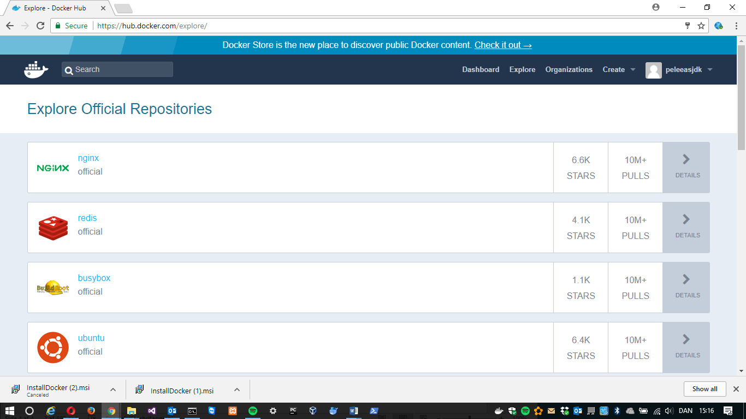
Assignment 4: Access different containers
You have two ways to access the registry of containers
(for more information see https://www.youtube.com/watch?v=NYfKsgDv_yA&t=45s&index=2&list=PLtWgqZUXAsNhMnuVgkP-nIuuKrRHuVF4Q ):
- Manually typing commands, to get an images (container) from http://hub.docker.com
docker pull <<container/images>>
- Using the Kitematic tool, which follow with the installation of the Docker in Windows. Click on the Docker icon and from the menu then open the tool Kitematic.

If you cannot open the tool, you properly need to copy the Kitematic–folder from ‘C:\Program Files\Docker Toolbox’ to ‘C:\Program Files\Docker’ – Then try again.

The username and password to Kitematic is the same as you created in assignment 3.

The Kitematic should look like this:
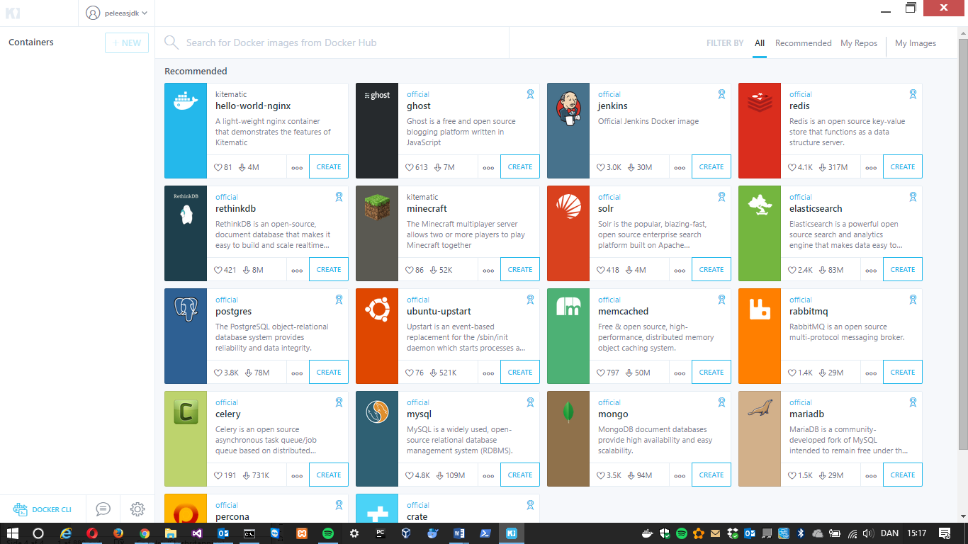

From here you can create (i.e. download an images /container) the application you will like to run in Docker at your computer.

Appendix A
Assignment A: Other host OS than windows

In assignment 1, you are installing the Docker on a Windows computer. If you would like to install on other OS here are some tips. First installed, the other three assignment you should be able to more or less follow.
MAC/OSX:
Help video: https://www.youtube.com/watch?v=h401q_YtAQA
Docker installation guide: https://docs.docker.com/docker-for-mac/install/

LINUX/UBUNTU:
Docker installation guide: https://docs.docker.com/engine/installation/linux/docker-ce/ubuntu/

General installation Page from Docker
https://docs.docker.com/engine/installation/

